You have discovered that inventory of Off Road Helmet and Road Helmet in Miami distribution center is running low and does not have sufficient number to fulfill the order. As GBI has a good business relationship with Olympic Protective Gear, you decided to order the product from them. Details of the order as follows:

Material | PO Quantity | Delivery Date | Net Price | Currency | Plnt
OHMT1### | 60 | (two weeks from today) | 25.00 | USD | MI00
RHMT1### | 150 | (two weeks from today) | 25.00 | USD | MI00

When received and accepted by vendor, a PO creates a legally binding contract between two parties. A goods receipt document will be created referencing to the purchase order thereby ensuring that GBI receive the products ordered within the timeframes requested and in quality condition.

Goods on hand will be increased and an accounting document will be generated recognizing the value associated with these goods.

Issue a payment to Rapids Nuts n Bolts to settle the Accounts Payable. Bank Account number for the payment process is 100000, Invoice Number: INVOICE 00515-### and Tax Code is XI. A journal entry is made to Accounts Payable for Rapids Nuts n Bolt and to the bank checking account in the G/L.


 | MM 1: Create Purchase Order- ME21N
Exercise Use the SAP Easy Access Menu to create a purchase order. Time 5 min
Task Create a Purchase Order (PO) for the Road and Off-road helmets. Submit the PO to the vendor, Olympic Protective Gear. When received and accepted by the vendor, the PO creates a legally binding contract between the two parties.
Name (Position) Tirrell Winsten (Buyer)
In order to create a purchase order, follow the SAP Easy Access menu path:  Logistics ► Materials Management ► Purchasing ► Purchase Order ► Create ► Vendor/Supplying Plant Known |  | Menu path
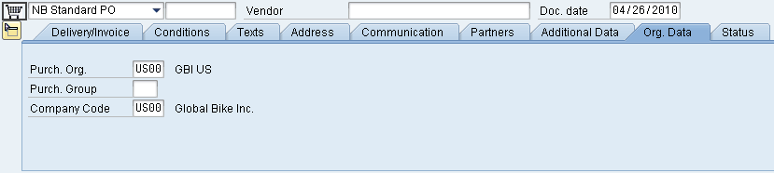
In the Vendor field, press F4 to find the number for Olympic Protective Gear in Atlanta. On the Vendors (General) tab, enter your three-digit number (###) as Search term and Atlanta in the City field. In the result list, double-click on the vendor number to select it |  | ###  Atlanta
Back on the Create Purchase Order screen, open the header data by clicking on Header.
Select or enter US00 for Purchasing Org, N00 for Purch. Group, and US00 for Company Code. Then click on . |  | US00  N00  US00
Open the item list by clicking on Item Overview. You have to enter the following materials and information (as shown below). You may use the F4 help to search and select both helmets (off-road and road). In order to do so, use the Material by Material Type search tab, select Trading Goods as Material Type and enter *### (e.g. *012 if your number is 012) as Material. Then, double-click the respective helmet to select it.  Click on the Enter icon . If you receive a system message whether the delivery date can be met accept it with Enter for both line items.  Go to Conditions tab in the Header section and record the total value of the purchase order: ______________ (5,250.00 USD).  Then go to the Conditions tab in the Item Detail section and record the value of both line items. You switch between items by using the and icons.  OHMT1###: ______________ (1,500.00 USD)  RHMT1###: ______________ (3,750.00 USD)  Now, your screen should look like shown below. |  | Trading Goods  *###
  Material | PO Quantity | Delivery Date | Net Price | Currency | Plnt
  OHMT1### | 60 | (two weeks from today) | 25.00 | USD | MI00
  RHMT1### | 150 | (two weeks from today) | 25.00 | USD | MI00
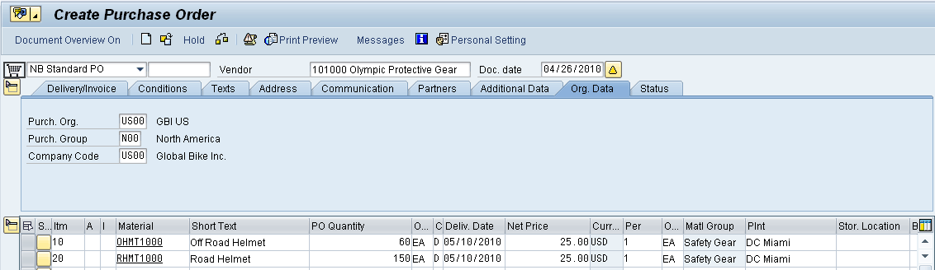
Click on to save the purchase order. A message will appear. To view the system messages, choose . The following message should appear.
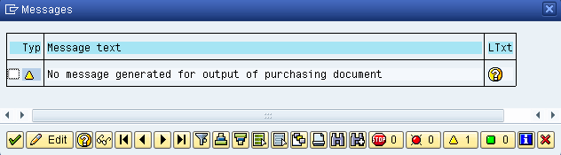
The message tells you that you are creating a purchase order, but have not generated any output to notify the selected vendor. Select to continue. Then click on again. This time we will save past the message indicating that no output device (i.e. Printer, FAX, EDI) was found to communicate this PO to the vendor. Select .
Note that SAP will assign a purchase order document number (bottom-left of the screen). |  | Purchase order document number
The purchase order screen is again blank, ready for another purchase order to be entered. Click on the exit icon to return to the SAP Easy Access Menu.

 | MM 2: Create Goods Receipt for Purchase Order- MIGO_GR
Exercise Use the SAP Easy Access Menu to create a goods receipt. Time 5 min
Task Receive into inventory the stock items ordered from Olympic Protective Gear in the previous exercise. A goods receipt document will be created referencing our purchase order thereby ensuring that we receive the products ordered within the timeframes requested and in quality condition. Goods on hand will be increased and an accounting document will be generated recognizing the value associated with these goods.
Name (Position) Tatiana Karsova (Receiving Clerk)
To create a goods receipt, follow the menu path:  Logistics ► Materials Management ► Inventory Management ► Goods Movement ► Goods Receipt ► For Purchase Order ► GR for Purchase Order (MIGO)  This will produce the following screen. |  | Menu path
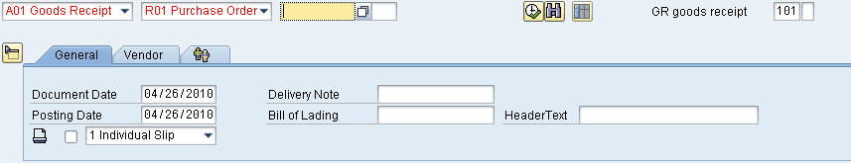
Make sure that the Movement type (top-right corner) is set to GR goods receipt 101. Enter your PO number from the previous exercise. If you do not have the number, find it by using the F4 help (Purchasing Document per Vendor tab or Purchasing Document for Material tab). Then press Enter. |  | 101  PO number
If a line is grayed out minimize the Item Detail Data by selecting (Close Detail Data). Ensure that the box in the OK column is checked for each item. Checking it indicates that you want to adopt it into the goods receipt document. |  | OK
In the SLoc column, enter Storage Location TG00 (Trading Goods) for both line items. Then click on to save your goods receipt. |  | TG00
Note that the SAP system will assign a unique number for this new goods receipt document. This number will appear in a message at the lower-left corner of the screen. Click on the exit icon to return to the SAP Easy Access Menu. |  | Goods receipt document number

 | MM 3: Create Invoice Receipt from Vendor- MIRO
Exercise Use the SAP Easy Access Menu to create an invoice receipt. Time 5 min
Task Enter an invoice received from Olympic Protective Gear for 5,250.00 USD associated with the recent PO and goods receipts. This invoice will be posted to an existing G/L expense account in your Chart of Accounts and saved as an Accounts Payable to Olympic Protective Gear. It will be settled by issuing a check to Olympic Protective Gear at a later date. The invoice is presented below in order to support you making the necessary journal entry.
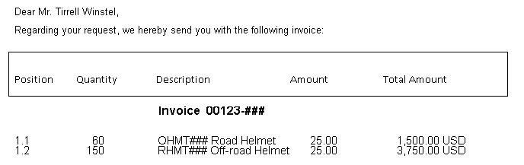
Name (Position) Silvia Cassano (Accounts Payable Specialist)
To enter an invoice, follow the menu path:  Logistics ► Materials Management ► Logistics Invoice Verification ► Document Entry ► Enter Invoice  This will produce the following screen. |  | Menu path
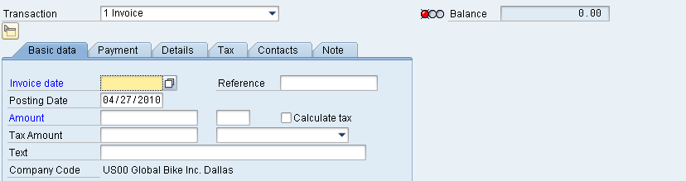
Enter today’s date as Invoice Date (you may use F4 to display the calendar and press Enter to select today’s date). Then, in the Amount field enter the total amount from the invoice document above and select Tax Code XI (drop-down field right of Tax amount field). As Text, enter ‘INVOICE 00123-###’ (replace ### with your number). Check whether your screen looks like shown below. |  | today’s date  5,250.00  XI  INVOICE 00123-###
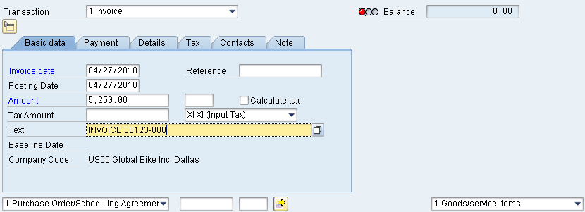
Then choose Purchase Order/Scheduling Agreement in the bottom drop-down list and enter your PO number from the first exercise in the text field next to it. Again, to find it you may use F4 and helpful search criteria such as vendor. Click on . |  | PO number
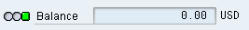
If the transaction is entered correctly (in respect to Debits and Credits), we will have a green light with a $0 balance.
We want to view what the actual postings will look like in the general ledgers. It is here that we can ensure that the Debit/Credit posting is correct and that the accounts are affected correctly. Use the button to see whether the postings are correct.
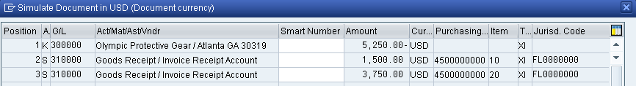
Press to save the invoice receipt. The system will again create a unique document number. |  | Invoice document number
Click on the exit icon to return to the SAP Easy Access Menu.

 | MM 4: Post Payment to Vendor- F-53
Exercise Use the SAP Easy Access Menu to post a payment to a vendor. Time 5 min
Task Issue a payment to Olympic Protective Gear to settle the Accounts Payable. A journal entry is made to Accounts Payable for Olympic Protective Gear and to the bank checking account in the G/L.
Name (Position) Silvia Cassano (Accounts Payable Specialist)
To post a payment to a vendor, follow the menu path:  Accounting ► Financial Accounting ► Accounts Payable ► Document Entry ► Outgoing Payment ► Post |  | Menu path
First, enter today’s date as Document Date. If requested, enter Company Code US00 and Currency/Rate USD. In the Bank data field group, for Account use F4 to find and select 100000 (Bank Account) and enter the amount you are going to pay (5,250.00). |  | today’s date  US00  USD  100000  5,250.00
In the Open item selection field group, search for the account number for your Olympic Protective Gear (use search term ###) and populate it into the Account field. All other settings remain unchanged. Make sure that your screen looks like the one shown below. |  | ###
Select . The following screen will appear.
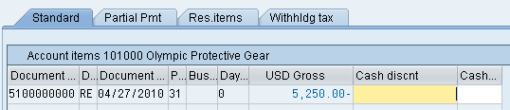
If the Not Assigned field on the bottom of the screen is not equal 0.00 USD, then double-click on your invoice amount (USD Gross). Then, the invoice selected will turn blue. Review the Not assigned balance on the bottom of the screen. Click on to post your payment. Again, the system creates a unique document number. |  | Payment document number
The Post Outgoing Payments screen is again blank, ready for another payment to be entered. Click on the exit icon to return to the SAP Easy Access Menu and as no data will be lost accept the SAP warning message with Yes. |  | Yes
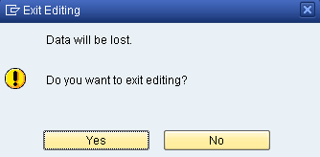

 | MM 5: Display Vendor Line Items
Exercise Use the SAP Easy Access Menu to display vendor line items. Time 5 min
Task Display and confirm the activity and associated balance for the Accounts Payable for Olympic Protective Gear. You should see both a credit and debit posting indicating the receipt of the invoice and the issuance of a payment to settle this balance due to Olympic Protective Gear.
Name (Position) Shuyuan Chen (Chief Accountant)
To do this, follow the menu path:  Accounting ► Financial Accounting ► Accounts Payable ► Account ► Display/Change Line Items |  | Menu path
In the Vendor field, search for the number for your Olympic Protective Gear supplier (use search term ###). Enter US00 as Company Code and select All items in the Line Item Selection section. Then, click on . A similar screen to the one shown below should appear. |  | ###  US00  All items
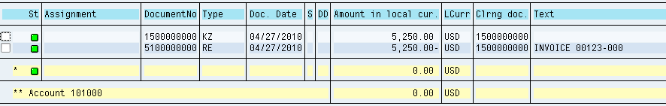
You can see that all of the postings made to our vendor have been cleared. Double-click on the Invoice Line (RE). Select to view the G/L line items. |  | RE
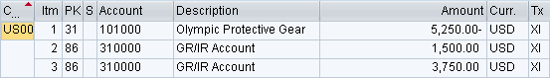
Click on to go back to the invoice line items, and double-click on the Vendor Payment Line (KZ). Select to view the G/L line items. |  | KZ
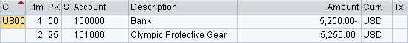
Click on the exit icon three times to return to the SAP Easy Access Screen.

